User Guide
The Microsoft Dynamics CRM Customization Comparison Utility allows users to upload two customization.xml files to compare differences in entities, attributes, forms, views, workflows, security roles, entity maps, and relationships. This tool can be used each time a set of customizations is exported from one system and imported to another system prior to import to view what changes will be overwritten in the target customization file.

Microsoft Dynamics CRM Customization Comparison Utility
After receiving the files for the Microsoft Dynamics CRM Customization Comparison Utility, run the setup wizard to install the tool on the client or server where the tool will be run from. Once complete, run the executable file from the location where you installed the Microsoft Dynamics CRM Configuration Data Utility application. The default location is C:\Program Files\Microsoft CRM Tools\CRM Customization Comparison Utility.

When the application opens, simply browse to the .xml or .zip file that was created when exporting customizations from a source Microsoft Dynamics CRM environment. Next, select the .xml or .zip file that was created when exporting customizations from the Target system where you will be importing the source customizations to. When a .zip file is used, make sure that only one customization.xml file exists.

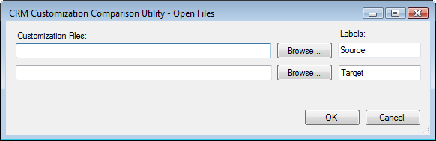

The results of the comparison appear in a grid to show a consolidated view of the changes. The following key can be used to identify what has changed between the Source and Target files:
- Indicates that there were no changes between the Source and Target files for that item.
- Indicates that changes were found between the Source and Target files for that item.
- Indicates that the item was found in the Target file but not in the Source file.
- Indicates that the item was found in the Source file but not in the Target file.
The items compared include entities, roles, workflows, entity maps, and relationships. From the entities, you can view changes to attributes, forms, and system views.

To view the details of what is different between the two .xml files, drill down into each item by clicking the symbol and click on the item you would like to review. In the bottom pane, the .xml code where a difference was found will be highlighted appropriately.

The example below shows the user reviewing the roles where one role was added to the Target system but was not found in the Source system. The user highlighted the Producer role and was able to view the .xml from the Target system for this role. These results could then be used to decide whether or not that role should also be added to the Source application for testing purposes.

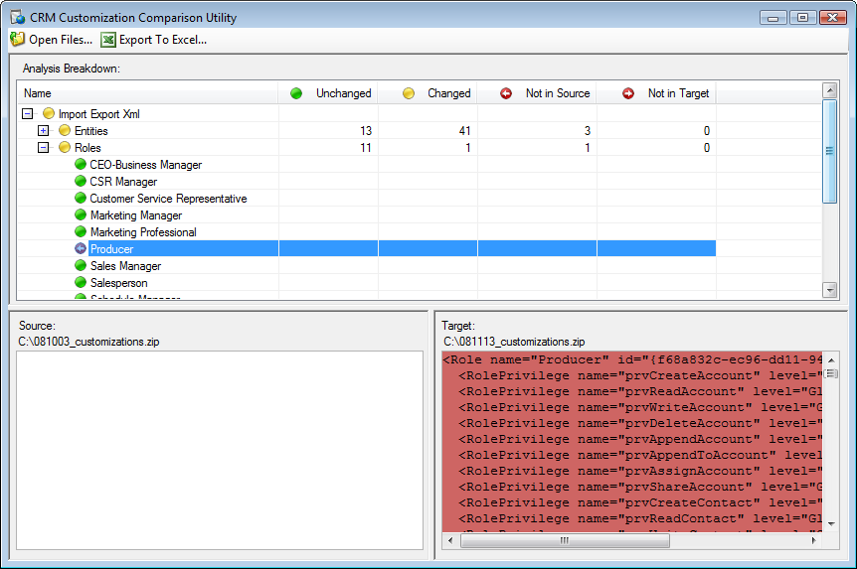

In addition, to reviewing the output in the grid, the results of the comparison can also be exported to Microsoft Excel by clicking Export to Excel. The results in the spreadsheet show each element along with the element type, the parent entity, if applicable, and whether or not the element was different between the Source and the Target files. To quickly view only elements that changed, simply use the filter feature in Excel to view only Changed in the Result column.

Element Name | Element Type | Parent Entity | Result
account | Entities | NA | Changed
accountcategorycode | Attributes | account | Unchanged
accountcategorycodename | Attributes | account | Unchanged
accountclassificationcode | Attributes | account | Unchanged
accountclassificationcodename | Attributes | account | Unchanged
accountid | Attributes | account | Changed

